Sanitation Marketers
Preparing & Conducting Workshops & Meetings

Tips & tricks and things you should not forget

Illustration made by Vincent
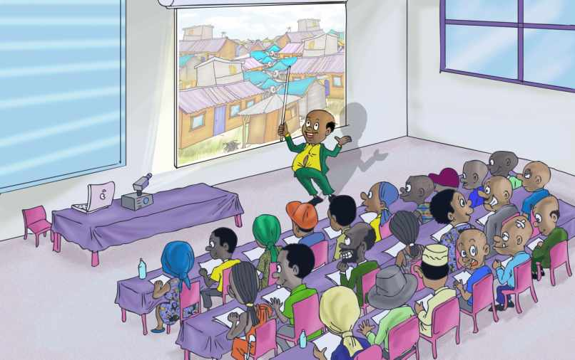
Table of Contents
Venue: Preparing the Venue 2
Slides: Preparing a PowerPoint Presentation 2
Presenting: Presenting a PowerPoint Presentation 4
Feedback: What’s after your PowerPoint Presentation? 6
Evaluation: How presentations are appraised by participants 6
Acronyms 6
References (please follow or enter the links) 7

Preparing & Conducting Workshops & Meetings

Tips & tricks and things you should not forget

Venue: Preparing the Venue
Your venue should meet a number of requirements. The venue (room/hall) should:
- Be quiet.
- Be well ventilated and not too hot or too cold.
- Have enough and comfortable chairs (everybody should be able to sit comfortably).
- Have sufficient tables (everybody should be able to take notes).
- Allow for the active participation of all (No-one should have to sit behind a pillar, etc.). In other words, everyone in the hall should be able to listen and talk to everyone else.
- Provide the opportunity for elderly people or people who have hearing or sight difficulties to sit on the first row.
If necessary, you should organise the tables and chairs in such a way that everybody can see each other (a horseshoe setup). Only if the number of participants is very large should you consider creating rows.
Please ensure the display table is well organized and at a strategic position. Have the scale models, toolkits and squatting pan etc. displayed well.

Slides: Preparing a PowerPoint Presentation
- Ask yourself before you start preparing your presentation (slides):
  - What are the key objectives of the workshop?
  - What are the main objectives I want to achieve with the presentation?
  - What are the main messages?
  - Do I need to illustrate some of the messages, figures, etc.?
  - Who will be in my audience, what is their background and level of understanding? Make sure all participants will be able to understand you. Do not write your presentation for the 2 VIPs (Bwana Mkubwa) who are present but for all the participants.
  - Is the title of your presentation clear and to the point?

- Make sure that if you use a presentation you have used before that you change the date, venue, etc. It is embarrassing if on the 14th of August 2014 in Mumias you present to Sanitation Marketers the “2011 Diani Beach Resort Workshop; Presentation for Managing Directors”.
- Do not make too many slides. Some experts say that if a presentation has more than 10 slides there is something wrong with it or with your message. Some of the SafiSan slides are longer (up to 20 slides). The reason is simply that these presentations have not been prepared by the persons presenting them. That’s why we felt there have to be more slides and that slides have to have a bit more text.
- Do not put too much text on your slide. If the text really contains important details, keep sentences short and do not use very “complicated” or “expensive” words if the same message can be communicated with a simple word. Depending on the amount, less is more.
- Do not use a large variety of fonts, font-sizes, transitions, special effects etc. You want to pass your message, not to impress your audience by showing off your elaborate PowerPoint skills.
- Make sure that there is sufficient contrast between your text (including the text and figure presented in tables, graphs, etc.) and background. Some things obviously work better than others:

SafiSan | SafiSan | SafiSan | SafiSan | SafiSan
Safisan | Safisan | Safisan | Safisan | Safisan
SafiSan | SafiSan | SafiSan | SafiSan | SafiSan
SafiSan | SafiSan | SafiSan | SafiSan | SafiSan

- Every slide should have its own message but there should be a logical link between the previous and the next slide.
- Using illustrations (figures, tables, graphs, animations, pictures, cartoons). Only when they add important information or make an abstract point more concrete. The size of the cartoons should be large enough but be careful not to disfigure them.
- Font-size. If your audience is large some people will be sitting in the back of the room of hall. 24 font size
- Number your slides and tell your audience how many slides you are going to present.
- Use of abbreviations & jargon. Make sure you never use abbreviations or names your audience may not be familiar with. Not everybody knows that the YKWTGA may stand for the “Young Kenyan Women Tea Growers Association”.
- Using the work of others. If you use in your presentation a table, a picture or a text (quote) of someone else, make sure you acknowledge that person or organisation. Instead of citing the sources all on one slide, cite the sources you referenced as you present them throughout the PowerPoint presentation.
- Make sure you save your work often. Look it over at least 5 times and run the spell checker before you save your file.
- Make a back-up. You have put in a lot of effort in preparing your PowerPoint presentation. Make sure you save the last version of your presentation, keep and carry a back-up of the same. You may find out that someone else’s computer is used for all presentations at the workshop. Therefore, always carry your presentation also on a USB stick.

Presenting: Presenting a PowerPoint Presentation
Here are a few tips that will help to give a better presentation:
- Check before you start presenting if:
  - The wall socket has “power”.
  - If you have an extension cable (if required).
  - The projector is working and you know how to operate it.
  - You can connect your computer/tablet to the beamer.
  - Your projector is placed on a stable table (a sound foundation) and if people cannot trip over cables.
  - The room/hall is (can be made) dark enough.
  - The wall or screen are flat and allow for clear viewing.
  - The image is sharp enough (if necessary, adjust your projector).
  - There is not too much outside noise or any other disturbance.
  - Everybody in the room/hall can see and read your slides (this requires you walking to the back of the hall).
  - Do you have or need a laser pointer?
  - Do you want someone to operate the computer/mouse for you (“next slide please”).
  - Do you need to give printouts of the slides to all participants?
  - Do the participants need additional write-ups (hand-outs) that can help them to get a clearer picture?
- Ask for the attention of the audience before you start your presentation. Do not just start presenting but make sure that everybody is present and paying attention. Getting your audience organised and paying attention sets the tone and ensures impact.
- Give a short summary of the topics you want to address during your presentation. You may decide to include a “summary (table of contents) slide” just after your “title slide”. Also tell your audience how long you expect your presentation to take.
- Do not speak too fast. If you speak to fast, perhaps just to make sure you finish on time, this may create the impression that you are in a hurry. Don’t forget that your audience need to understand and digest what you are telling them.
- Speak with a clear and loud enough voice. Some presenters often get the remark; “can you speak louder we can’t hear you out here.” Make sure you adjust your voice to the size of your audience or the hall or use a microphone.
- Vary the tone of your voice. This makes your presentation more lively and interesting to hear...and it keeps your audience awake.
- The occasional joke or funny remark can help you to keep your presentation lively and your audience awake. However, do not turn your presentation into a one-man (-woman) show. You have come with a serious message and you are not a stand-up comedian. Make sure that your audience feel that you believe in what you say.
- If you need a translator. You are presenting in English and your slides are in English….but most people in your audience only speak Kiswahili. Oops! Please find out which language to use. You may decide to present your English presentation whilst speaking Kiswahili (not a very elegant solution) or you may decide to speak English (because some participants do not speak Kiswahili) and use a translator. If you use a translator, he or she should be given the opportunity to see the presentation (slides) beforehand. Make sure you sit together with your translator before the presentation and discuss the way both of you are going to present. For example, do not speak for 5 minutes and then expect your translator to translate your remarks (sentences) in 15 seconds. The longer you talk the more your translator is likely to forget… or distort.
- Look at your audience. Do not look at your slides the whole time (in other words, do not, most of the time, show your back to your audience). Some presenters tend to look at the ceiling or out of the window instead of at their audience; also not very good.
- Never skip a slide. Some people use the same presentation for a wide variety of audiences. Instead of selecting the appropriate slides for each audience, they prefer to present the same presentation (over and over again) and make adjustments during their presentation by skipping slides (“oh this one, we don’t need”). Not good! Skipping slides leaves your audience wondering why they are not supposed to see particular slides (Are we stupid? Are we given some old and recycled presentation?).
- Do not focus on one person in your audience all the time. Some presenters tend to start looking (staring) at the same person most of the time during their presentation. This can be a friend, a person of authority (your boss or a VIP) or someone who seems to agree (nodding) or disagree with what you are saying. This is not a good habit as it makes the person who is targeted by your eyes feel nervous (or very important) and the others may feel left out. Try to make everyone feel part of your presentation by looking at all your participants.
- Do not read out what is written on your slides (Boring and….most people can read). The text on your slides should get reinforced or emphasised through what you are saying. Sometimes your slide serves as an illustration or a starting point of a small discourse (verbal presentation, question, etc.).
- If your presentation is rather long be conscious to inform your audience and request for some additional time.
- Ask questions. Instead of presenting or explaining you can also try to involve your audience by asking questions. The answer may be found on your slide or not. By asking questions a presentation becomes more lively and interesting and the message much clearer.
- Do not use the same words, all the time. Using words and gap fillers like “ehh” “whatever”, “you know” makes your presentation irritating.
- Challenges: the after lunch presentation should not be too long. If possible, provide drinks to the audiences and ensure comfortable ventilation.
- Thank your audience for their attention and participation before you hand the floor back to the facilitator. It is either up to you or it’s the task of the facilitator to ask the audience if there are any questions or points for discussion. It is important, however, that the presenter and facilitator know who is expected to do what.

Feedback: What is after your PowerPoint Presentation?
You have given your presentation. What is next?
- Q & A session. Allow enough time for your audience to ask questions and answer them with a moderate pace. Important is that they understand and get the most out of your presentation.
- Group work can help measure and evaluate the impact of your presentation to your audience. In case you prepared prior questions on the topic, engage your audience with the questions in group discussions to get their feedback. Some shy audience may prefer to give their feedback via group work.
- How to record feedback? Flipcharts, brief questionnaires, email etc.
- Main objectives achieved. Remember to highlight to them how the main objectives of the workshop presentation have been achieved through your presentation.

Evaluation: How presentations are appraised by participants
If your audience is asked to evaluate your presentation, what aspects would they consider?
- The quality of your slides (boring, does not convey the message, spelling mistakes, layout).
- Your presentations skills (audibility, movements and gestures, humour, eye contact, facial expressions etc.)
- The duration of your presentation.
- How organised you are (venue, equipment, points etc.)
- Level of concern and care towards your audience.
- How you conclude your presentation.
- Your choice of words. Polite language will be highly regarded.

Acronyms
PP: PowerPoint
Q & A: Question and Answer
WSTF: Water Services Trust Fund

References (please follow or enter the links)

How to make effective presentation - SlideShare
www.slideshare.net/.../how-to-make-effective-present

Designing Effective PowerPoint Presentations - Free Courseware at ...
(freecourseware.uwc.ac.za/.../media:how-to-make-effe)

Making effective powerpoint-based presentations
http://www.engr.psu.edu/ce/enve/logan/web_presentations/Effective_ppt_presentations-Logan-11-5-08.pdf

10 Tips for More Effective PowerPoint Presentations - Lifehack.org
www.lifehack.org/.../10-tips-for-more-effecti...‎

How to Create an Effective PowerPoint:
http://www.wikihow.com/Create-an-Effective-PowerPoint

________________________________________________

